Hawaii Organ Donor Enrollment Day
Blog or newsletter copy

Option 1
Heart transplant recipient

New heart brings a lifetime of joy to a Hawai‛i family

Meet Parish Chang, heart recipient – Saved by an organ donor
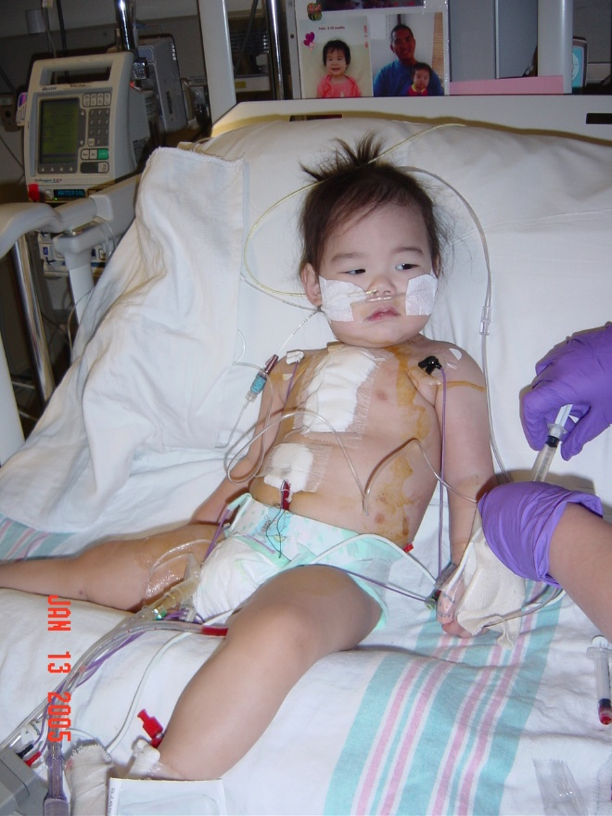 | 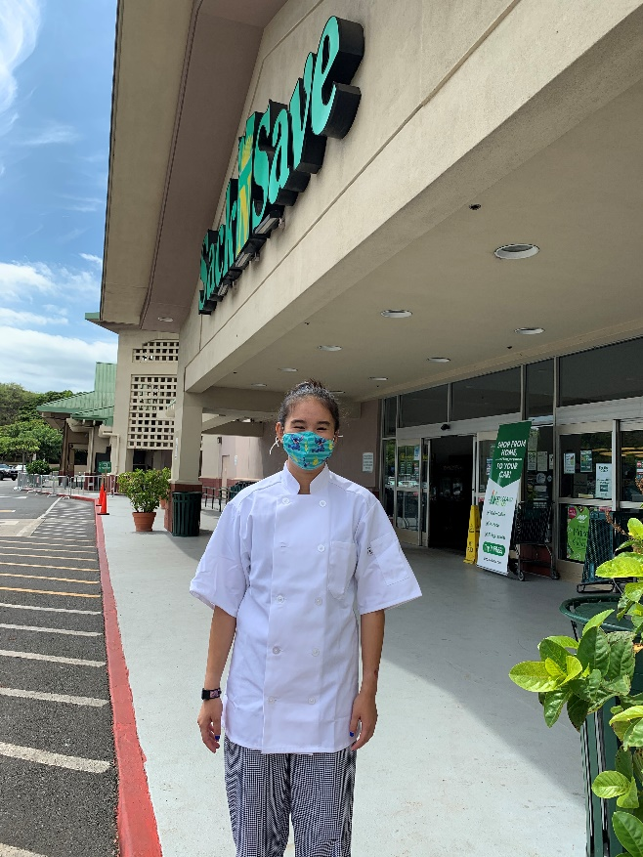

Paris was just 10-months old when her parents noticed an unusual swelling in her hands and feet. They took her to Kapiolani Medical Center where they learned that Paris had cardiomyopathy and would need a heart transplant. She was immediately medevaced to Lucille Packard Children’s Hospital at Stanford’s Pediatric Intensive Care Unit in California where she waited two months before receiving a heart transplant.

She was immediately medevaced to Lucile Packard Children’s Hospital at Stanford’s Pediatric Intensive Care Unit in California where she waited two months for her heart. Just days before her first birthday, Paris received the heart of a 16 month old pediatric donor, named Charlie.

This past January Paris celebrated her 17th birthday as well as the 16th anniversary of her heart transplant. She is a junior in high school and she is thriving. As part of her high school curriculum, she is enrolled in a volunteer mentorship working at the Sack ‘n Save bakery. She loves hiking Oahu’s mountain trails and photography. She looks forward to returning to playing volleyball after the pandemic ends.
Today is Organ Donor Enrollment Day. A day to inspire kamaʻāina to sign up as organ, eye and tissue donors, a decision that could help someone like Paris one day.

Sign up online by clicking here (insert LLH unique registration link.)

Option 2

Organ Donor Story

Duke DeRego - The Hero of His Family
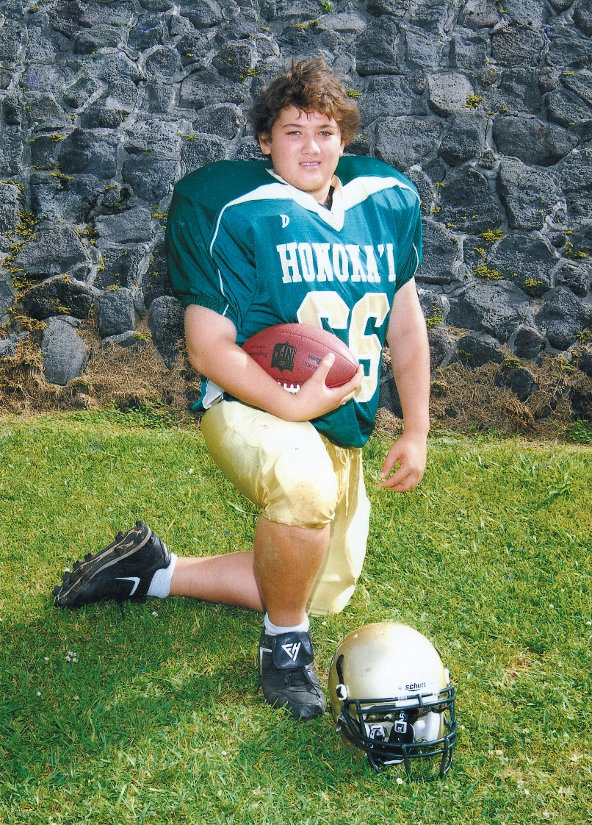

Bronson “Duke” Nainoa De Rego, became an organ donor after a senseless accident took his life. Duke or “Dukie” as he was called by family and friends, was a freshman in high school on the Big Island at the time of his death. Duke passed away from a head injury that he sustained when he was thrown from a golf cart. He was 14 years old.

Duke loved sports and finally got to play football as a high school freshman . His mother, Shirley DeRego, remembers Duke as a loving and happy child who always seemed to have a smile to share. He enjoyed basketball, baseball, boxing, and finally got to play football as a freshman at Honokaʻa High School. He is remembered by his family as the “big little brother” who loved his family, his dog Moku, and his friends.

“You could always count on Duke if you needed any help at all. He was so kind and giving,” his mother recalls.

As a family, the DeRegos made the decision to donate Duke’s organs, knowing it would help save lives. This was the ultimate gift of life well-lived. He made a difference in the lives of three men and gave sight to two women. He is the hero of the DeRego family.

Knowledge is power. A simple act of “checking the box” on a driver license or state ID application form is all it takes to possibly save a life.

The Facts About Saving Lives
- Organ donation is often possible even with certain health conditions.
- There is no age limit to be an organ donor. There is no age limit to donate organs or to sign up as an organ donor. People in their 50s, 60s, 70s and beyond have been both organ donors and transplant recipients.
- The organ donation process follows strict national guidelines to ensure fairness and equity
- Because organ donation saves lives, most religions celebrate it as a final act of kindness.
- Registering as an organ donor does not change your medical care. Doctors and medical staff are legally obligated to save your life. Register as an organ and tissue donor at RegisterMe.org/HawaiiDonorEnrollmentDay
- Be part of a life-saving movement. One organ donor can save up to eight lives. To learn more about organ, eye and tissue donation visit legacyoflifehawaii.org.

