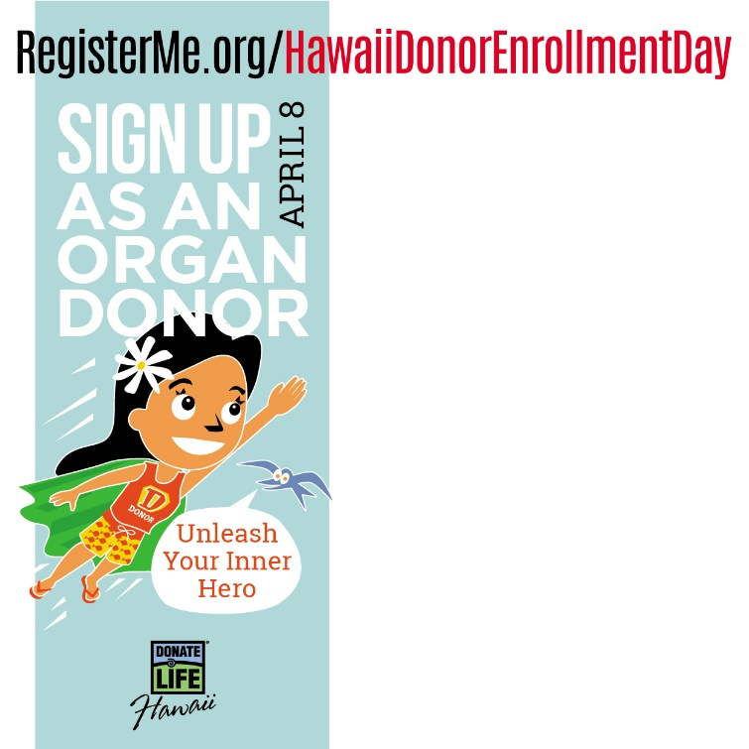  April 8th is Organ Donor Enrollment Day in Hawai‛i. Encourage your friends and family to register as organ/tissue donors.  Every one who registers to be an #organdonor can save up to 8 lives and improve the lives of 50 others through tissue donation. Make a difference on April 8th and register online as a lifesaving organ donor: RegisterMe.org/HawaiiDonorEnrollmentDay #DonorDayHI2021 #legacyoflife | 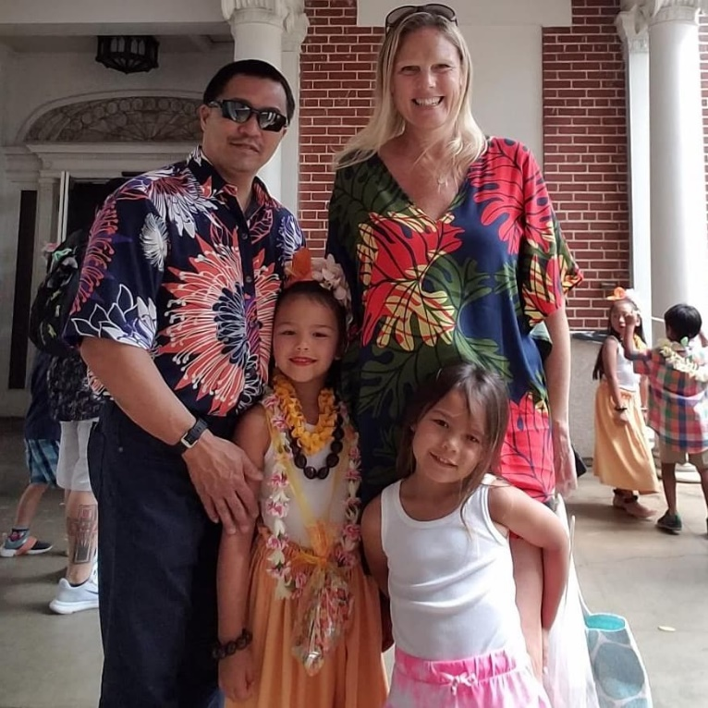  In a year’s time Sarah went from a happy bride to be to a patient at death’s door with her liver was failing. Her fiancé kept the momentum going and their dreams were restored when a registered donor saved her life. Today, the Chees are the proud parents of two beautiful daughters. Three lives - all made possible by an organ donor. Unleash your inner hero and enroll as an organ donor on April 8 – Hawai‛i Donor Enrollment Day. #donordayHI
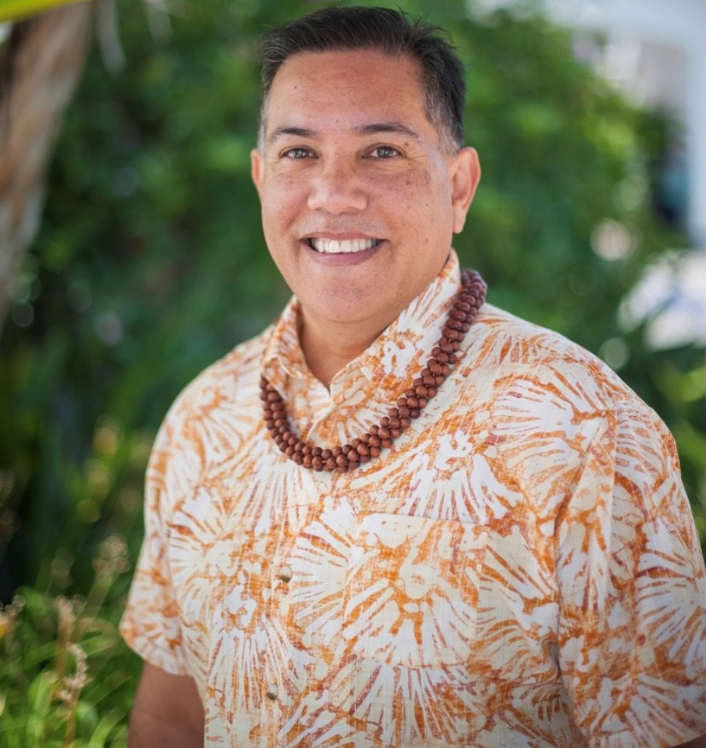  Sean Keoni nearly died of pulmonary fibrosis, a lung disease that caused both of his lungs to fail. His life was saved by a registered donor who left behind the gift of life that saved Sean’s life. Unleash your inner hero and enroll as an organ, eye and tissue donor on April 8th at RegisterMe.org/HawaiiDonorEnrollmentDay. Already registered? Spread the word and encourage your friends and family to enroll as organ, eye and tissue donors, on this special day. #donordayHI | Sample supporting text for graphics provided below:  - Every person who registers to become an #organdonor can save up to 8 lives and improve the lives of 50 others through tissue donation. Make a difference on 4/8 and register online as a lifesaving organ donor at RegisterMe.org/HawaiiDonorEnrollmentDay  #DonorDayHI #LegacyofLifeHawaii  - Make a difference for the more than 350 people waiting for a lifesaving organ transplant. Today is Organ Donor Enrollment Day. Unleash your inner hero and sign up as a lifesaving #organdonor at RegisterMe.org/HawaiiDonorEnrollmentDay  #DonorDayHI #LegacyofLifeHawaii  - •Today is Organ Donor Enrollment Day! Join the movement and help save lives by asking friends, family and colleagues to sign up today as an organ and tissue donor. Visit RegisterMe.org/HawaiiDonorEnrollmentDay to register online. #DonorDayHI #LegacyofLifeHawaii

